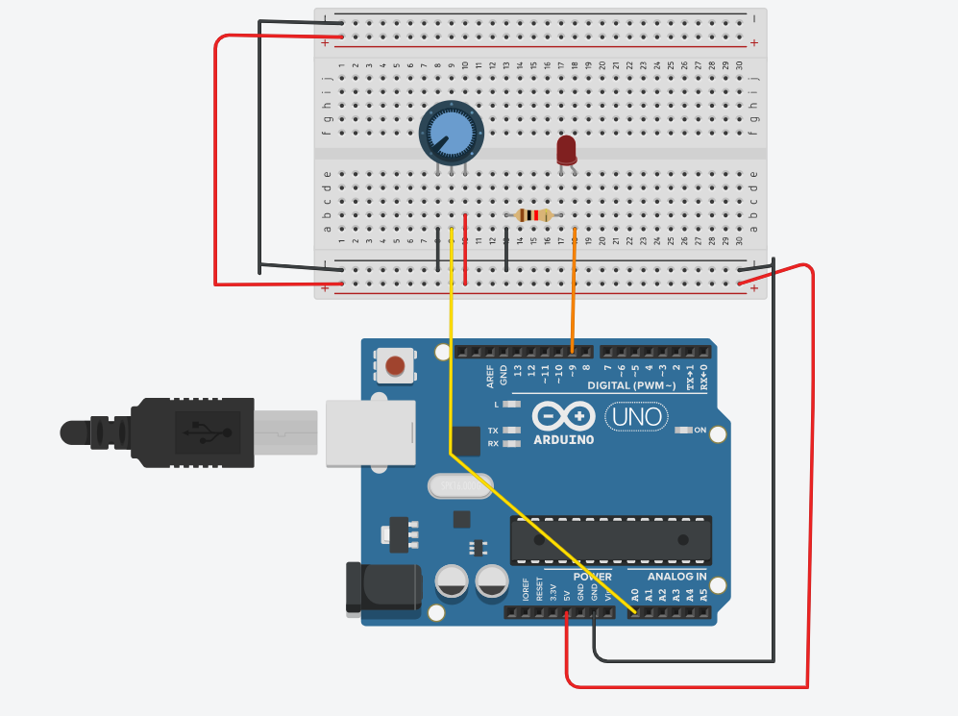

int ledPin=9;
int potPin=A0;
int potValue = 0;
int brightness = 0;

void setup() {
Serial.begin(9600);
pinMode(ledPin, OUTPUT);

}

void loop() {
potValue=analogRead(potPin);
Serial.println("potentiometer: ");
Serial.println(potValue);

brightness = map(potValue, 0, 1023, 0, 255);
analogWrite(ledPin,
brightness);

delay(100);
}

Observation : As the wiper rotates the intensity of LED changes.

